Major  (C)  Closing | 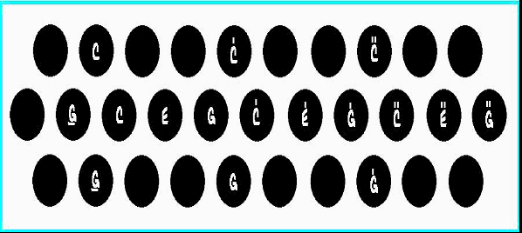

I Minor  (Cm)  Closing | 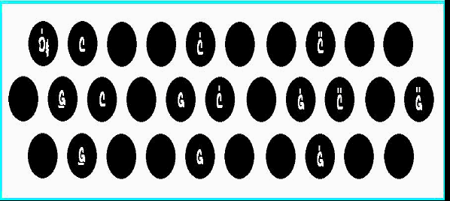

II Dom7  (D7)  Closing | 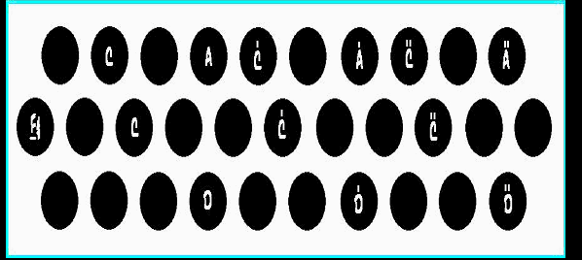

II Minor7  (Dm7)  Closing | 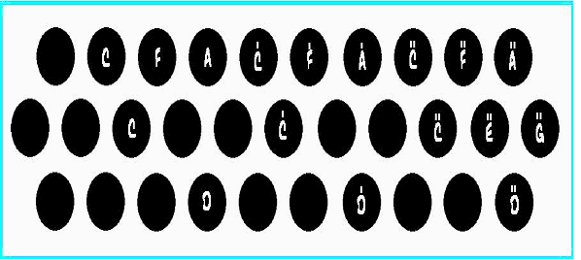

III Min7  (Em7)  Closing | 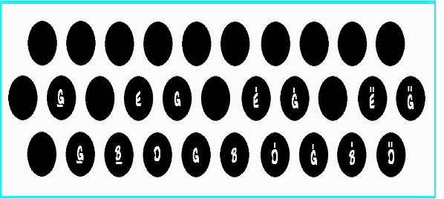

IV Dom7  (F7)  Closing | 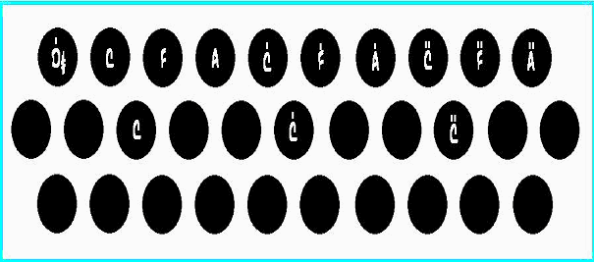

V Dom7  (G7)  Closing | 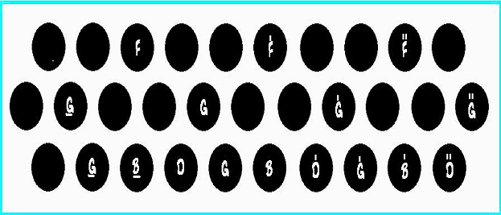

VI Dom7  (A7)  Closing | 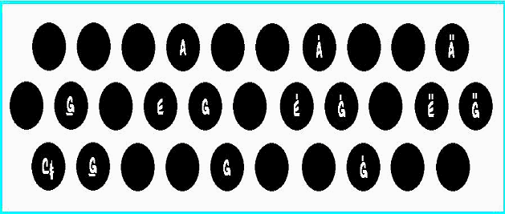

VI Minor7  (Am7)  Closing | 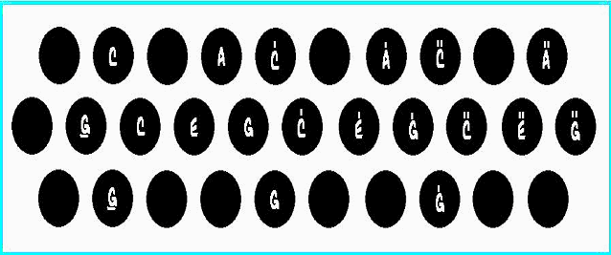

VII Dom7  (B7)  Closing | 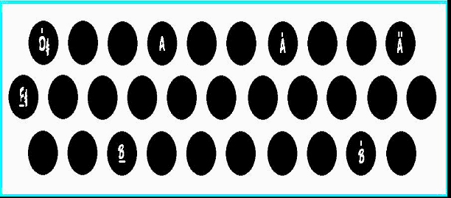

VII Minor7  (Bm7)  Closing | 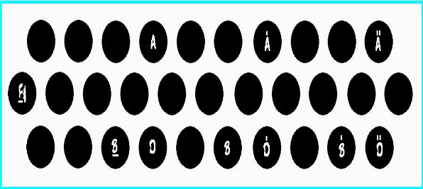

IV# Min7  (F#m7)  Closing | 

